S . J . Public School

Jaipur

*A Project Report  
on*

***Restaurant Management System***

For

CBSE 2079-2020 Examination

[As a part of the Informatics Practices Course (065)]

SUBMITTED BY

***KUNARK RAWAT***

[Roll No ]

Under the Guidance of:

***C.M. Agarwal Sir***

CERTIFICATE

This is to certify that the Project / Dissertation entitled ***Restaurant Management System*** is a bonafide work done by ***Kunark Rawat*** of class ***XII Science*** Session 2019-20 in partial fulfillment of ***CBSE’s AISSCE Examination 2019-20*** and has been carried out under my direct supervision and guidance. This report or a similar report on the topic has not been submitted for any other examination and does not form a part of any other course undergone by the candidate.

## ………………………… ……………………………..

## Signature of Student Signature of Teacher/Guide

**{Kunark Rawat} {C.M. Agarwal Sir}**

**Roll No.:**

### 

**Place: Jaipur** **Signature of Principal**

**Date: {Mrs. Saroj Singh Mam }**

ACKNOWLEDGEMENT

I

undertook this Project work, as the part of my XII-Informatics Practices course. I had tried to apply my best of knowledge and experience, gained during the study and class work experience. However, developing software system is generally a quite complex and time-consuming process. It requires a systematic study, insight vision and professional approach during the design and development. Moreover, the developer always feels the need, the help and good wishes of the people near you, who have considerable experience and idea.

I would like to extend my sincere thanks and gratitude to my teacher **C.M. Agarwal Sir.** I am very much thankful to our Principal **Mrs. Saroj Singh Mam** for giving valuable time and moral support to develop this software.

I would like to take the opportunity to extend my sincere thanks and gratitude to my father **Mr. Rajesh Kr. Gupta** and my mother **Mrs. Sangeeta Gupta** for being a source of inspiration and providing time and freedom to develop this software project.

I also feel indebted to my friends **Master Sudarshan Pal** and **Master Bhupendra Negi** for the valuable suggestions during the project work.

**Kunark Rawat**

**Class XII Science**

## Informatics Practices Project

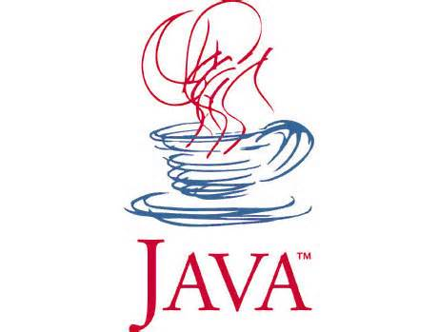

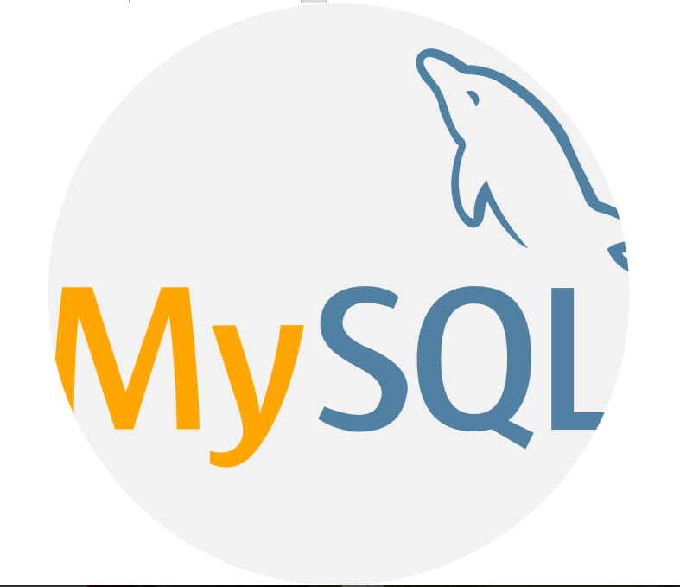

**C O N T E N T S**

1**. Introduction** 6

**2. Objective & Scope of the Project** 7

**3. Theoretical Background** 9

**4. Problem Definition & Analysis** 16

**5. System Implementation** 18

5.1 The Hardware used: 18

5.2 The Softwares used: 18

**6. System Design & Development** 19

6.1 Database Design: 19

6.2 I/O Forms Design & Event Coding: 24

**7. User Manual** 83

7.1 How to install: 83

7.2 Working with Software: 84

**8. References**  85

**1. Introduction**

This software project is developed to automate the functionalities of a School. The purpose of the software project is to develop the Management Information System (MIS) to automate the record of the admin , customer , Items table like – sweets , juices,soft drinks,snacks expenditure with a view to enhance the decision making of the functionaries.   
A MIS mainly consists of a computerized database, a collection of inter-related tables for a particular subject or purpose, capable to produce different reports relevant to the user. An application program is tied with the database for easy access and interface to the database. Using Application program or front-end, we can store, retrieve and manage all information in proper way.

This software, being simple in design and working, does not require much of training to users, and can be used as a powerful tool for automating a school System.

During coding and design of the software Project, Java NetBeans IDE, a powerful front-end tool is used for getting Graphical User Interface (GUI) based integrated platform and coding simplicity. As a back-end a powerful, open source RDBMS, My SQL is used as per requirement of the CBSE curriculum of Informatics Practices Course.

**2. Objective & Scope of the Project**

T

he objective of the software project is to develop a computerized MIS to automate the functions of a restaurant. This software project is also aimed to enhance the current record keeping system, which will help managers to retrieve the up-to-date information at right time in right shape.

The proposed software system is expected to do the following functionality-

* To provide a user friendly, Graphical User Interface (GUI) based integrated and centralized environment for MIS activities.
* The proposed system should maintain all the records and should generate the required reports and information when required.
* To provide graphical and user-friendly interface to interact with a centralized database based on client-server architecture.
* To identify the critical operation procedure and possibilities of simplification using modern IT tools and practices.

In its current scope, the software enables user to retrieve and update the information from centralized database designed with MySQL . This software does not require much training time of the users due to limited functionality and simplicity.

During the development of Restaurant Management System project, Java NetBeans IDE, a powerful, open source event-driven form-based development environment is used for modular design and future expandability of the system.

Despite of the best effort of the developer, the following limitations and functional boundaries are visible, which limits the scope of this application software.

1. This software can store records in pre-designed format in soft copy. There is no facility yet to produce customized reports. Only specified reports are covered.
2. There is no provision to do admission or transfer of a student or a staff member however it can be developed easily with the help of adding modules.
3. It facilitates user to view add and update record.

So far as future scope of the project is concerned, firstly it is open to any modular expansion i.e. other modules or functions can be designed and embedded to handle the user need in future. Any part of the software and reports can be modified independently without much effort.

**3. Theoretical Background**

## 

## 3.1 What is Database?

### 

### Introduction and Concepts:

A database is a collection of information related to a particular subject or purpose, such as tracking customer orders or maintaining a music collection. Using any RDBMS application software like MS SQL Server, MySQL, Oracle, Sybase etc, you can manage all your information from a single database file. Within the file, divide your data into separate storage containers called tables. You may and retrieve the data using queries.

A table is a collection of data about a specific topic, such as products or suppliers. Using a separate table for each topic means you can store that data only once, which makes your database more efficient and reduces data-entry errors. Table organises data into columns (called fields) and rows (called records).

A Primary key is one or more fields whose value or values uniquely identify each record in a table. In a relationship, a primary key is used to refer to specific record in one table from another table. A primary key is called foreign key when it is referred to from another table.

To find and retrieve just the data that meets conditions you specify, including data from multiple tables, create a query. A query can also update or delete multiple records at the same time, and perform built-in or custom calculations on your data.

### *Role of RDBMS Application Program:*

A computer database works as a electronic filing system, which has a large number of ways of cross-referencing, and this allows the user many different ways in which to re-organize and retrieve data. A database can handle business inventory, accounting and filing and use the information in its files to prepare summaries, estimates and other reports. The management of data in a database system is done by means of a general-purpose software package called a Database Management System (DBMS). Some commercially available DBMS are MS SQL Server, MS ACCESS, INGRES, ORACLE, and Sybase. A database management system, therefore, is a combination of hardware and software that can be used to set up and monitor a database, and can manage the updating and retrieval of database that has been stored in it. Most of the database management systems have the following capabilities:

* Creating of a table, addition, deletion, modification of records.
* Retrieving data collectively or selectively.
* The data stored can be sorted or indexed at the user's discretion and direction.
* Various reports can be produced from the system. These may be either standardized report or that may be specifically generated according to specific user definition.
* Mathematical functions can be performed and the data stored in the database can be manipulated with these functions to perform the desired calculations.
* To maintain data integrity and database use.

The DBMS interprets and processes users' requests to retrieve information from a database. In most cases, a query request will have to penetrate several layers of software in the DBMS and operating system before the physical database can be accessed. The DBMS responds to a query by invoking the appropriate subprograms, each of which performs its special function to interpret the query, or to locate the desired data in the database and present it in the desired order.

## logo-mysql3.2 What is My SQL ?

The management of data in a database system is done by means of a general-purpose software package called a Database Management System (DBMS). Some commercially available RDBMS are MS SQL Server, MS ACCESS, INGRES, ORACLE, and Sybase.

MySQL, the most popular Open Source SQL database management system, is developed, distributed, and supported by Oracle Corporation. MySQL is named after co-founder Monty Widenius's daughter, My. The name of the MySQL Dolphin (our logo) is “Sakila,”.

* **MySQL is a database management system.**

A database is a structured collection of data. It may be anything from a simple shopping list to a picture gallery or the vast amounts of information in a corporate network. To add, access, and process data stored in a computer database, you need a database management system such as MySQL Server. Since computers are very good at handling large amounts of data, database management systems play a central role in computing, as standalone utilities, or as parts of other applications.

* **MySQL is based on SQL.**

A relational database stores data in separate tables rather than putting all the data in one big storeroom. This adds speed and flexibility. The SQL part of “MySQL” stands for “Structured Query Language.” SQL is the most common standardized language used to access databases and is defined by the ANSI/ISO SQL Standard. The SQL standard has been evolving since 1986 and several versions exist. In this manual, “SQL-92” refers to the standard released in 1992, “SQL:1999” refers to the standard released in 1999, and “SQL:2003” refers to the current version of the standard.

* **MySQL software is Open Source.**

Open Source means that it is possible for anyone to use and modify the software. Anybody can download the MySQL software from the Internet and use it without paying anything. If you wish, you may study the source code and change it to suit your needs. The MySQL software uses the GPL (GNU General Public License),

* **The MySQL Database Server is very fast, reliable, and easy to use.**

If that is what you are looking for, you should give it a try. MySQL Server also has a practical set of features developed in close cooperation with our users. You can find a performance comparison of MySQL Server with other database managers on our benchmark page. MySQL Server was originally developed to handle large databases much faster than existing solutions and has been successfully used in highly demanding production environments for several years. Although under constant development, MySQL Server today offers a rich and useful set of functions. Its connectivity, speed, and security make MySQL Server highly suited for accessing databases on the Internet.

* **MySQL Server works in client/server or embedded systems.**

The MySQL Database Software is a client/server system that consists of a multi-threaded SQL server that supports different backends, several different client programs and libraries, administrative tools, and a wide range of application programming interfaces (APIs).

**The Main Features of MySQL**

* Written in C and C++.
* Works on many different platforms.
* Uses multi-layered server design with independent modules.
* Provides transactional and nontransactional storage engines.
* Designed to make it relatively easy to add other storage engines. This is useful if you want to provide an SQL interface for an in-house database.
* Uses a very fast thread-based memory allocation system.
* Executes very fast joins using an optimized nested-loop join.
* Implements SQL functions using a highly optimized class library that should be as fast as possible. Usually there is no memory allocation at all after query initialization.
* Password security by encryption of all password traffic when you connect to a server.
* Support for large databases. We use MySQL Server with databases that contain 50 million records. We also know of users who use MySQL Server with 200,000 tables and about 5,000,000,000 rows.
* MySQL client programs can be written in many languages. A client library written in C is available for clients written in C or C++, or for any language that provides C bindings.
* APIs for C, C++, Eiffel, Java, Perl, PHP, Python, Ruby, and Tcl are available, enabling MySQL clients to be written in many languages.
* The Connector/ODBC (MyODBC) interface provides MySQL support for client programs that use ODBC (Open Database Connectivity) connections.
* The Connector/J interface provides MySQL support for Java client programs that use JDBC connections. Clients can be run on Windows or Unix. Connector/J source is available.

## 3.3 What is NetBeans IDE ?

NetBeans started as a student project (originally called Xelfi) in the Czech Republic in 1996. The goal was to write a Delphi-like Java IDE in Java. Xelfi was the first Java IDE (Integrated Development Environment) written in Java, with its first pre-releases in 1997. Xelfi was a fun project to work on, especially since Java IDE space was uncharted territory at that time. The project attracted enough interest that these students, once they graduated, decided that they could market it as a commercial product. Soliciting resources from friends and relatives for a web space, they formed a company around it.

Soon after, they were contacted by [Roman Stanek](http://www.google.com/search?q=roman+stanek&hl=en&lr=&c2coff=1&client=safari&rls=en&start=10&sa=N), an entrepreneur who had already been involved in several startups in the Czech Republic. He was looking for a good idea to invest in, and discovered Xelfi. He met with the founders; they hit it off, and a business was born.

In the spring of 1999, [NetBeans DeveloperX2](http://www.internetnews.com/dev-news/article.php/75561) was released, supporting Swing. The performance improvements that came in JDK 1.3, released in the fall of 1999, made NetBeans a viable choice for development tools. By the summer of 1999, the team was hard at work re-architecting DeveloperX2 into the more modular NetBeans that forms the basis of the software today.

Something else was afoot in the summer of 1999: [Sun Microsystems](http://www.sun.com) wanted better Java development tools, and had become interested in NetBeans. It was a dream come true for the NetBeans team: NetBeans would become the flagship tool set of the maker of Java itself! By the Fall, with the next generation of NetBeans Developer in beta, a deal was struck. Sun Microsystems had also acquired another tools company, During the acqusition, the young developers who had been involved in open-source projects for most of their programming careers, mentioned the idea of open-sourcing NetBeans. Fast forward to less than six months later, the decision was made that NetBeans would be open sourced. While Sun had contributed considerable amounts of code to open source projects over the years, this was Sun's first *sponsored* open source project, one in which Sun would be paying for the site and handling the infrastructure.

# Features of NetBeans

A free, open-source Integrated Development Environment for software developers. You get all the tools you need to create professional desktop, enterprise, web, and mobile applications with the Java platform, as well as C/C++, PHP, JavaScript, Groovy, and Ruby. NetBeans IDE 6.9 introduces the JavaFX Composer, support for JavaFX SDK 1.3, OSGi interoperability, support for the PHP Zend framework and Ruby on Rails 3.0, and more.

**4. Problem Definition & Analysis**

The hardest part of building a software system is deciding precisely what to build. No other part of the conceptual work is so difficult as establishing the detailed technical requirement. Defining and applying good, complete requirements are hard to work, and success in this endeavor has eluded many of us. Yet, we continue to make progress.

Problem definition describes the *What* of a system, not *How* . The quality of a software product is only as good as the process that creates it. Problem definition is one of the most crucial steps in this creation process. Without defining a problem, developers do not know what to build, customers do not know what to expect, and there is no way to validate that the built system satisfies the requirement.

Problem definition and Analysis is the activity that encompasses learning about the problem to be solved, understanding the needs of customer and users, trying to find out who the user really is, and understanding all the constraints on the solution. It includes all activities related to the following:

* Identification and documentation of customer’s or user’s needs.
* Creation of a document that describes the external behavior and the association constraints that will satisfies those needs.
* Analysis and validation of the requirements documents to ensure consistency, completeness, and feasibility
* Evolution of needs.

After the analysis of the functioning of a Restaurant management system, the proposed System is expected to do the following: -

* To provide a user friendly, Graphical User Interface (GUI) based integrated and centralized environment for computerized Restaurant management System.
* The proposed system should maintain all the records and transactions, and should generate the required reports and information when required.
* To provide graphical and user-friendly interface to interact with a centralized database based on client-server architecture.
* To identify the critical operation procedure and possibilities of simplification using modern IT tools and practices.

**5. System Implementation**

## 5.1 The Hardware used:

While developing the system, the used hardware are:

PC with Pentium IV processor or sometimes, PC with Celeron (1.7 GHz) processor having 256 MB RAM, SVGA and other required devices.

## 5.2 The Softwares used:

* Microsoft Windows® 7 as Operating System.
* Java NetBeans 6.9.1 as Front-end Development environment.
* MySQL as Back-end Sever with Database for Testing.
* MS-Word 2007 for documentation.

**6. System Design & Development**

## 

## 6.1 Database Design:

An important aspect of system design is the design of data storage structure. To begin with a logical model of data structure is developed first. A database is a container object which contains tables, queries, reports and data validation policies enforcement rules or contraints etc. A logical data often represented as a records are kept in different tables after reducing anomalies and redundancies. The goodness of data base design lies in the table structure and its relationship.

This software project maintains a database named **ip1** which contains the following tables.

### Table Design:

The database of Restaurant Management System contains 6 tables. The tables are normalized to minimize the redundancies of data and enforcing the validation rules of the organization. Most of the tables are designed to store master records. The tables screenshots are given below.

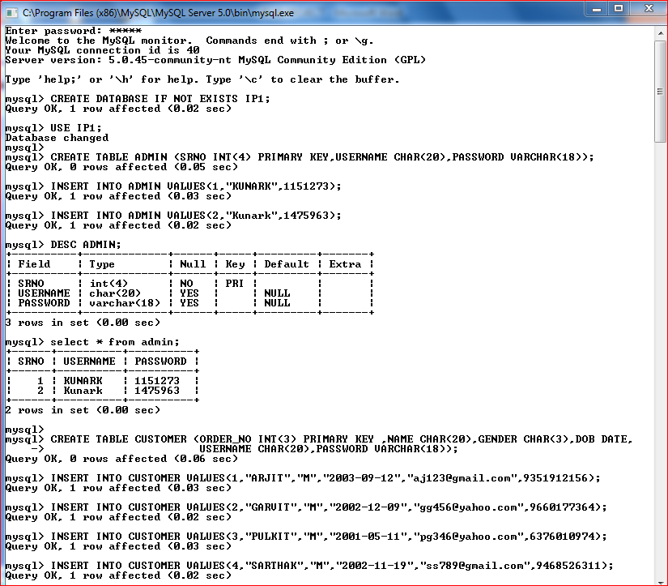 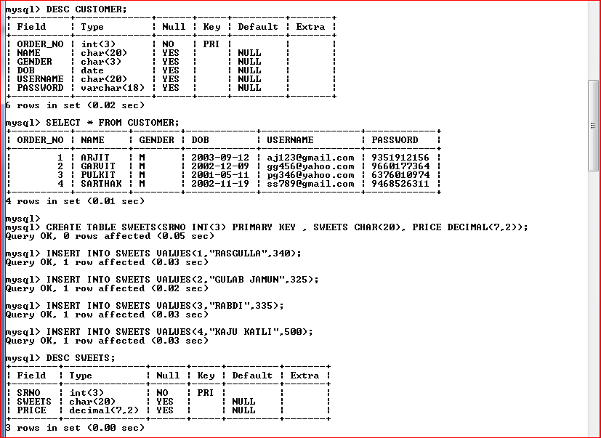 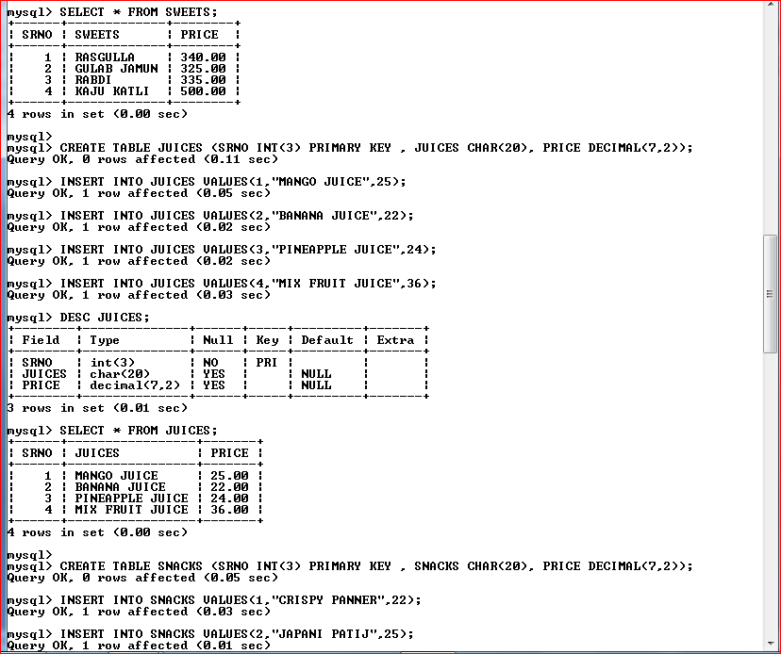 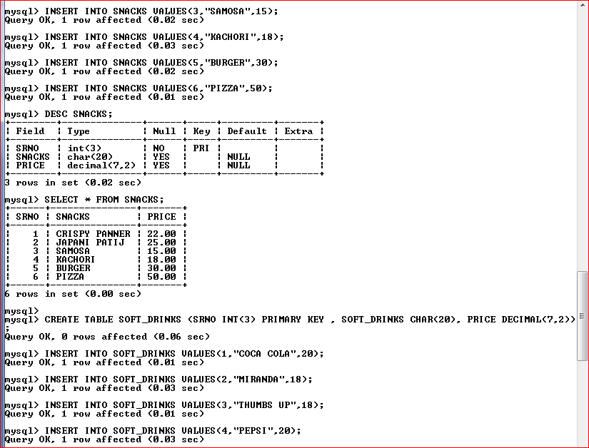

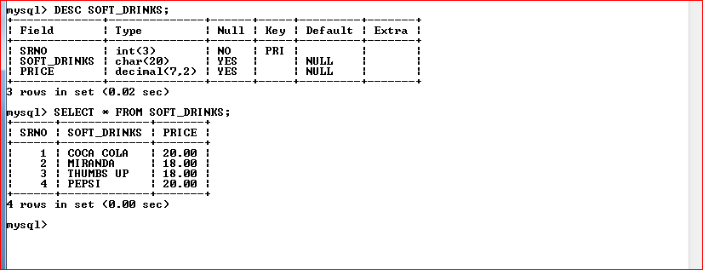

## 6.2 I/O Forms Design & Event Coding:

The software project for Restaurant management Management contains various forms along with programming codes. Forms (JFrames) and their event coding are given below.

***Frame:JFrame***

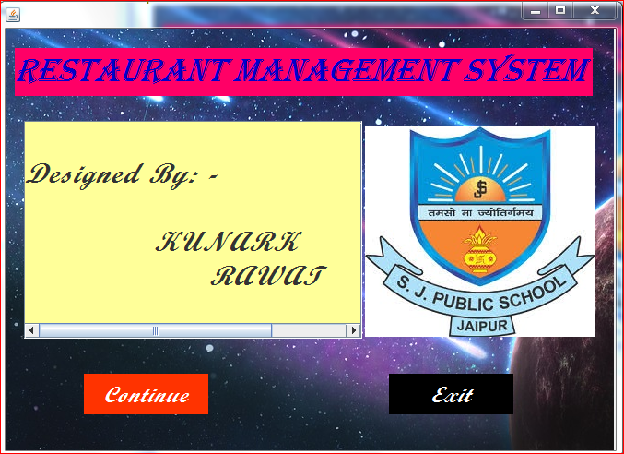

***Coding for JFrame***

**private void jButton2ActionPerformed(java.awt.event.ActionEvent evt)** {

this.setVisible(false);

new ip2().setVisible(true);

}

**private void jButton1ActionPerformed(java.awt.event.ActionEvent evt)** {

System.exit(0);}

***Frame:1st page***

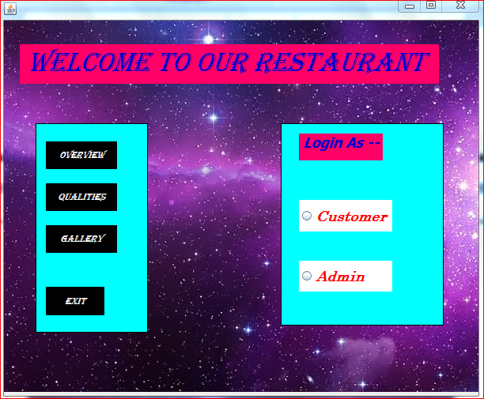

***Coding for JFrame --***

**private void jButton6jButton2ActionPerformed(java.awt.event.ActionEvent evt)** {

this.setVisible(false);

new ip11().setVisible(true); }

**private void jButton7jButton3ActionPerformed(java.awt.event.ActionEvent evt)** { this.setVisible(false);

new ip12().setVisible(true);

}

**private void jButton8jButton4ActionPerformed(java.awt.event.ActionEvent evt)** { this.setVisible(false);

new ip13().setVisible(true);

}

**private void jButton1ActionPerformed(java.awt.event.ActionEvent evt)** {

System.exit(0);

}

**private void jRadioButton1ActionPerformed(java.awt.event.ActionEvent evt)** {

this.setVisible(false);

new ip5().setVisible(true);

}

**private void jRadioButton2ActionPerformed(java.awt.event.ActionEvent evt)** {

this.setVisible(false);

new ip4().setVisible(true);}

***Frame:2nd page***

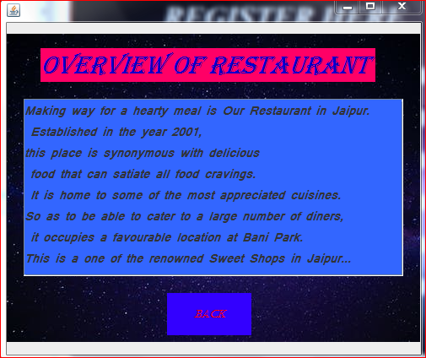

***Coding for JFrame --***

**private void jButton6ActionPerformed(java.awt.event.ActionEvent evt)** {

this.setVisible(false);

new ip2().setVisible(true);

}

***Frame:3rd page***

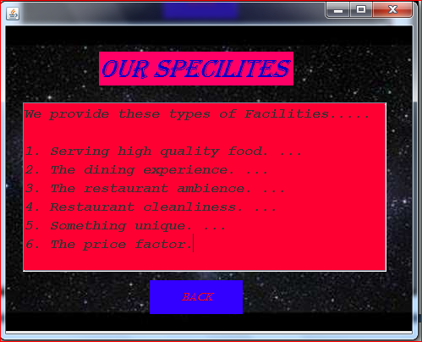

***Coding for JFrame --***

**private void jButton6ActionPerformed(java.awt.event.ActionEvent evt)** {

this.setVisible(false);

new ip2().setVisible(true);}

***Frame:4th page***

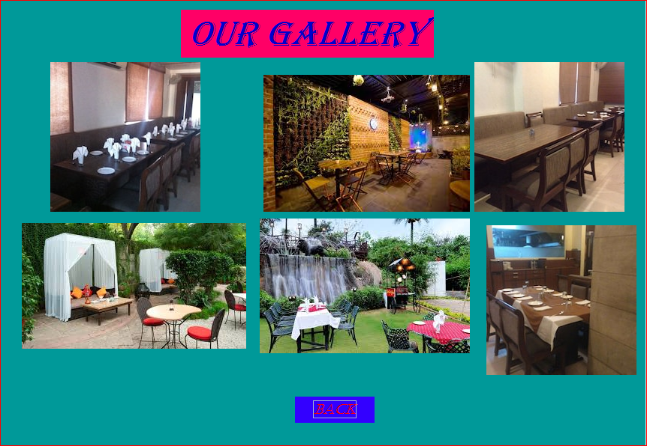

***Coding for JFrame --***

**private void jButton6ActionPerformed(java.awt.event.ActionEvent evt)** {

this.setVisible(false);

new ip2().setVisible(true);}

***Frame:5th page***

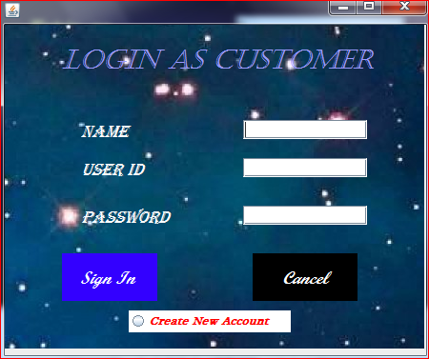

***Coding for JFrame --***

**private void jRadioButton3ActionPerformed(java.awt.event.ActionEvent evt)** {

this.setVisible(false);

new ip3().setVisible(true);}

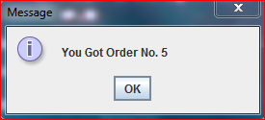

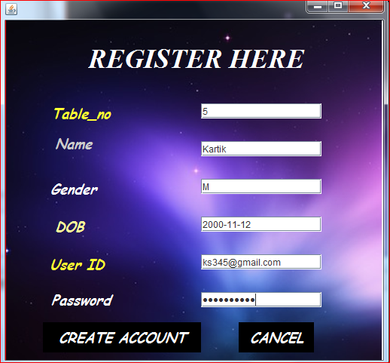

***Coding for JFrame --***

import java.sql.*;

import javax.swing.JOptionPane;

**public class ip3 extends javax.swing.JFrame {**

**public ip3() {**

**initComponents();**

try {

Class.forName("java.sql.DriverManager");

Connection con=DriverManager.getConnection("jdbc:mysql://localhost:3306/ip1","root","mysql");

String sql="Select table_no from customer";

Statement st=con.createStatement();

ResultSet rs= st.executeQuery(sql);

if(rs.last()) {

int table_no=Integer.parseInt(rs.getString("table_no"));

int c=table_no+1;

jTextField1.setText(""+c);

JOptionPane.showMessageDialog(null,"You Got Table No. "+jTextField1.getText()); }

}

catch(Exception e)

{

JOptionPane.showMessageDialog(this,"ERROR"+e.getMessage());

}

**}**

**private void jButton6jButton2ActionPerformed(java.awt.event.ActionEvent evt)** {

try {

Class.forName("java.sql.DriverManager");

Connection con=DriverManager.getConnection("jdbc:mysql://localhost:3306/ip1","root","mysql");

String table_no,name,gender,dob,user_id,password,sql;

table_no=jTextField1.getText();

name=jTextField2.getText();

gender=jTextField3.getText();

dob=jTextField4.getText();

user_id=jTextField5.getText();

password=new String(jPasswordField1.getPassword());

sql="insert into customer values('"+table_no+"','"+name+"','"+gender+"','"+dob+"','"+user_id+"','"+password+"')";

Statement st=con.createStatement();

st.executeUpdate(sql);

this.setVisible(false);

new ip5().setVisible(true);

JOptionPane.showMessageDialog(this,"YOU HAVE SUCCESSFULLY CREATED YOUR ACCOUNT \n REMEMBER YOUR USERID & PASSWORD");

}

catch(Exception e)

{

JOptionPane.showMessageDialog(this,"ERROR"+e.getMessage());

}

}

**private void jButton3ActionPerformed(java.awt.event.ActionEvent evt)** {

this.setVisible(false);

new ip2().setVisible(true);

}

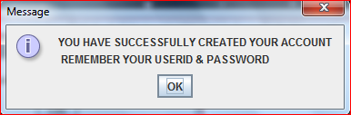

***Frame:6th page***

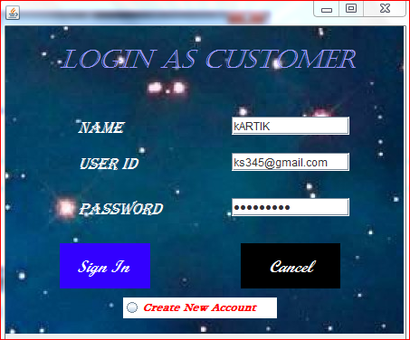

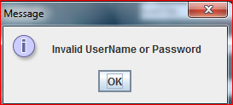

***Coding for JFrame –***

import java.sql.*;

import javax.swing.JOptionPane;

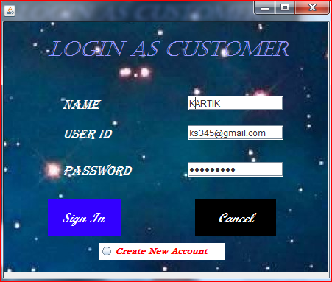

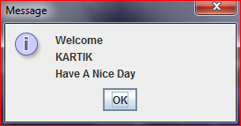

***Coding for JFrame –***

**private void jButton3ActionPerformed(java.awt.event.ActionEvent evt) {**

this.setVisible(false);

new ip2().setVisible(true);

}

**private void jButton2ActionPerformed(java.awt.event.ActionEvent evt) {**

try {

Class.forName("java.sql.DriverManager");

Connection con=DriverManager.getConnection("jdbc:mysql://localhost:3306/ip1","root","mysql");

String name,user_id,password,sql;

name=jTextField1.getText();

user_id=jTextField2.getText();

password=new String(jPasswordField1.getPassword());

sql="select * from customer where name ='"+name+"'and username='"+user_id+"'and password ='"+password+"'";

Statement st=con.createStatement();

ResultSet rs=st.executeQuery(sql);

if(rs.next())

{

this.setVisible(false);

new ip10().setVisible(true);

JOptionPane.showMessageDialog(this,"Welcome\n"+name+"\nHave A Nice Day");

}

else

{

JOptionPane.showMessageDialog(this,"Invalid Name or UserName or Password");

jPasswordField1.setText("");

}

}

catch(Exception e)

{

JOptionPane.showMessageDialog(this,"ERROR"+e.getMessage());

}

}

**private void jRadioButton3ActionPerformed(java.awt.event.ActionEvent evt)** {

this.setVisible(false);

new ip3().setVisible(true);

}

***Frame:7th page***

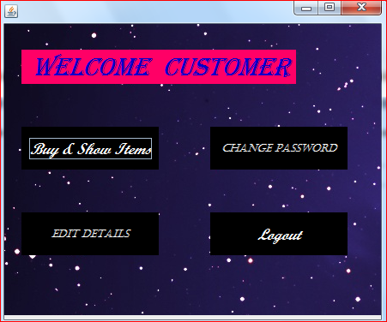

***Coding for JFrame –***

import javax.swing.JOptionPane;

**private void jButton3ActionPerformed(java.awt.event.ActionEvent evt)** {

this.setVisible(false);

new ip5().setVisible(true);

}

**private void jButton8ActionPerformed(java.awt.event.ActionEvent evt)** {

this.setVisible(false);

new ip17().setVisible(true);

}

**private void jButton4ActionPerformed(java.awt.event.ActionEvent evt)** {

this.setVisible(false);

new ip16().setVisible(true);

JOptionPane.showMessageDialog(this,"USE DISPALY TABLES\n..SWEETS\n..JUICES\n..SNACKS\n..SOFT DRINKS\nTO VIEW ITEMS");

}

**private** **void jButton9ActionPerformed(java.awt.event.ActionEvent evt)** {

this.setVisible(false);

new ip15().setVisible(true);

}

***Frame:8th page***

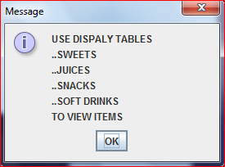 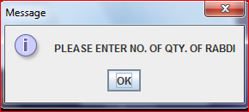

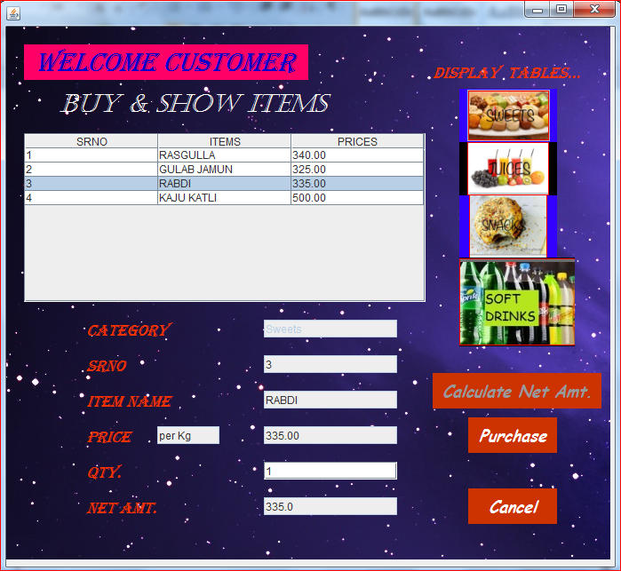

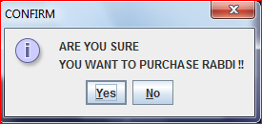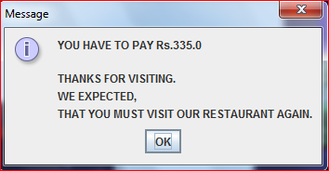

***Coding for JFrame –***

import java.sql.*;

import javax.swing.JOptionPane;

import javax.swing.table.DefaultTableModel;

**public ip16()** {

initComponents();

jTextField5.setText("1");

}

**private void jTable1MouseClicked(java.awt.event.MouseEvent evt)** {

int i=jTable1.getSelectedRow();

DefaultTableModel m=(DefaultTableModel)jTable1.getModel();

jTextField1.setText(m.getValueAt(i, 0).toString());

jTextField2.setText(m.getValueAt(i, 1).toString());

jTextField3.setText(m.getValueAt(i, 2).toString());

jButton7.setEnabled(false);

jTextField6.setText("");

jTextField5.setText("1");

jButton5.setEnabled(true);

JOptionPane.showMessageDialog(this,"PLEASE ENTER NO. OF QTY. OF "+jTextField2.getText());

jTextField5.setEditable(true);

}

**private void jButton10ActionPerformed(java.awt.event.ActionEvent evt)** {

DefaultTableModel tm=(DefaultTableModel)jTable1.getModel();

tm.setRowCount(0);

jTextField4.setText("sweets");

try {

Class.forName("java.sql.DriverManager");

Connection con=DriverManager.getConnection("jdbc:mysql://localhost/ip1","root","mysql");

Statement stmt=con.createStatement();

String query="select * from sweets";

ResultSet rs=stmt.executeQuery(query);

while (rs.next()) {

String Srno=rs.getString(1);

String Sweets=rs.getString(2);

String Price=rs.getString(3);

Object[] ob1={Srno,Sweets,Price};

tm.addRow(ob1);

jTextField7.setText("per Kg");

}

} catch (Exception e) {

JOptionPane.showMessageDialog(null,e.getMessage());

} }

**private void jButton4ActionPerformed(java.awt.event.ActionEvent evt)** {

DefaultTableModel tm=(DefaultTableModel)jTable1.getModel();

tm.setRowCount(0);

jTextField4.setText("juices");

try {

Class.forName("java.sql.DriverManager");

Connection con=DriverManager.getConnection("jdbc:mysql://localhost/ip1","root","mysql");

Statement stmt=con.createStatement();

String query="select * from juices";

ResultSet rs=stmt.executeQuery(query);

while (rs.next()) {

String Srno=rs.getString(1);

String Juices=rs.getString(2);

String Price=rs.getString(3);

Object[] ob1={Srno,Juices,Price};

tm.addRow(ob1);

jTextField7.setText("per Glass");

}

} catch (Exception e) {

JOptionPane.showMessageDialog(null,e.getMessage());

}

}

**private void jButton9ActionPerformed(java.awt.event.ActionEvent evt)** {

DefaultTableModel tm=(DefaultTableModel)jTable1.getModel();

tm.setRowCount(0);

jTextField4.setText("snacks");

try {

Class.forName("java.sql.DriverManager");

Connection con=DriverManager.getConnection("jdbc:mysql://localhost/ip1","root","mysql");

Statement stmt=con.createStatement();

String query="select * from snacks";

ResultSet rs=stmt.executeQuery(query);

while (rs.next()) {

String Srno=rs.getString(1);

String Snacks=rs.getString(2);

String Price=rs.getString(3);

Object[] ob1={Srno,Snacks,Price};

tm.addRow(ob1);

jTextField7.setText("per Plate");

}

} catch (Exception e) {

JOptionPane.showMessageDialog(null,e.getMessage());

}

}

**private void jButton3ActionPerformed(java.awt.event.ActionEvent evt)** {

DefaultTableModel tm=(DefaultTableModel)jTable1.getModel();

tm.setRowCount(0);

jTextField4.setText("soft_drinks");

try {

Class.forName("java.sql.DriverManager");

Connection con=DriverManager.getConnection("jdbc:mysql://localhost/ip1","root","mysql");

Statement stmt=con.createStatement();

String query="select * from soft_drinks";

ResultSet rs=stmt.executeQuery(query);

while (rs.next()) {

String Srno=rs.getString(1);

String Soft_Drinks=rs.getString(2);

String Price=rs.getString(3);

Object[] ob1={Srno,Soft_Drinks,Price};

tm.addRow(ob1);

jTextField7.setText("per Glass");

}

} catch (Exception e) {

JOptionPane.showMessageDialog(null,e.getMessage());

}

}

**private void jButton5ActionPerformed(java.awt.event.ActionEvent evt)** {

double a=Double.parseDouble(jTextField3.getText());

double b=Double.parseDouble(jTextField5.getText());

double c=a*b;

jTextField6.setText(""+c);

int s= JOptionPane.showConfirmDialog(this, "ARE YOU SURE\nYOU WANT TO PURCHASE "+jTextField2.getText() +" !!","CONFIRM",JOptionPane.YES_OPTION,JOptionPane.NO_OPTION);

if(s==JOptionPane.YES_OPTION){

jButton5.setEnabled(false);

jButton7.setEnabled(true);

}

else if(s == JOptionPane.NO_OPTION)

{

jTextField6.setText("");

jTextField5.setText("1");

}

else if(s == JOptionPane.CLOSED_OPTION)

{

jTextField6.setText("");

jTextField5.setText("1");

}

}

**private** **void jButton7ActionPerformed(java.awt.event.ActionEvent evt)** {

double a=Double.parseDouble(jTextField3.getText());

double b=Double.parseDouble(jTextField5.getText());

double c=a*b;

jTextField6.setText(""+c);

JOptionPane.showMessageDialog(this,"YOU HAVE TO PAY Rs.\t"+c+"\n\nTHANKS FOR VISITING.\nWE EXPECTED,\nTHAT YOU MUST VISIT OUR RESTAURANT AGAIN.");

jTextField1.setText("");

jTextField2.setText("");

jTextField3.setText("");

jTextField5.setText("1");

jTextField6.setText("");

jButton7.setEnabled(false);

jTextField5.setEditable(false);

}

**private void jButton8ActionPerformed(java.awt.event.ActionEvent evt)** {

this.setVisible(false);

new ip10().setVisible(true);

}

***Frame:9th page***

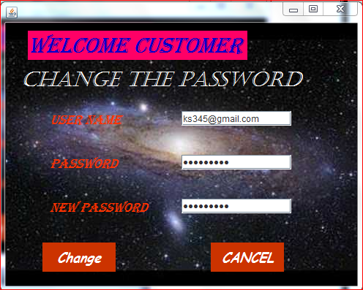

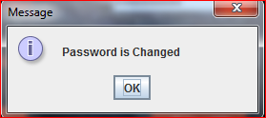

***Coding for JFrame –***

import java.sql.*;

import javax.swing.JOptionPane;

**private void jButton2ActionPerformed(java.awt.event.ActionEvent evt)** {

try {

Class.forName("java.sql.DriverManager");

Connection con=DriverManager.getConnection("jdbc:mysql://localhost:3306/ip1","root","mysql");

String user_id,password,new_password,sql;

user_id=jTextField1.getText();

password=new String(jPasswordField1.getPassword());

new_password=new String(jPasswordField2.getPassword());

sql="update customer set password='"+new_password+"' where username='"+user_id+"'and password='"+password+"'";

Statement st=con.createStatement();

int count=st.executeUpdate(sql);

if(count>0)

{

JOptionPane.showMessageDialog(null,"Password is Changed");

jPasswordField1.setText("");

jPasswordField2.setText("");

}

else

{

JOptionPane.showMessageDialog(this,"Invalid UserName or Password");

jPasswordField1.setText("");

jPasswordField2.setText("");

}

}

catch(Exception e)

{

JOptionPane.showMessageDialog(this,"ERROR"+e.getMessage());

}

}

**private void jButton3ActionPerformed(java.awt.event.ActionEvent evt)** {

this.setVisible(false);

new ip10().setVisible(true);

}

***Frame:10th page***

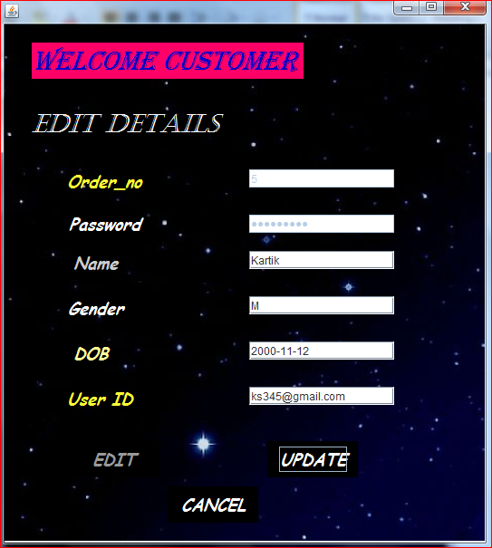

***Coding for JFrame –***

import java.sql.*;

import javax.swing.JOptionPane;

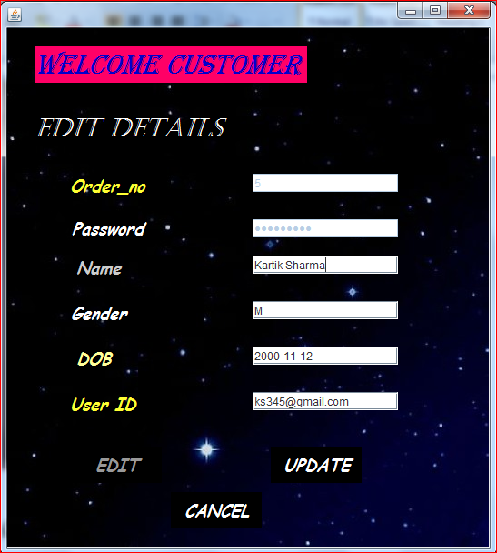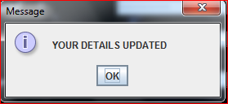

***Coding for JFrame –***

**private void jButton7jButton2ActionPerformed(java.awt.event.ActionEvent evt)** {

try {

Class.forName("java.sql.DriverManager");

Connection con=DriverManager.getConnection("jdbc:mysql://localhost:3306/ip1","root","mysql");

String order_no,name,gender,dob,user_id,password,sql;

order_no=jTextField1.getText();

password=new String(jPasswordField1.getPassword());

sql="Select * from customer where order_no ='"+order_no+"' and password ='"+password+"'";

Statement st=con.createStatement();

ResultSet rs= st.executeQuery(sql);

if(rs.next()) {

jTextField2.setText(rs.getString("name"));

jTextField3.setText(rs.getString("gender"));

jTextField4.setText(rs.getString("dob"));

jTextField5.setText(rs.getString("username"));

jTextField1.setEnabled(false);

jPasswordField1.setEnabled(false);

jButton6.setEnabled(true);

jButton7.setEnabled(false);

} else if(order_no.isEmpty()||password.isEmpty()) {

JOptionPane.showMessageDialog(this,"Entries are Compulsary");

} else {

JOptionPane.showMessageDialog(this,"Wrong Entries");

jTextField1.setText("");

jPasswordField1.setText("");

}

} catch(Exception e) {

JOptionPane.showMessageDialog(this,"ERROR"+e.getMessage());

} }

**private** **void jButton6jButton2ActionPerformed(java.awt.event.ActionEvent evt)** {

try {

Class.forName("java.sql.DriverManager");

Connection con=DriverManager.getConnection("jdbc:mysql://localhost:3306/ip1","root","mysql");

String order_no, name,gender,dob,user_id,sql;

order_no=jTextField1.getText();

name=jTextField2.getText();

gender=jTextField3.getText();

dob=jTextField4.getText();

user_id=jTextField5.getText();

sql="update customer set name='"+name+"',gender='"+gender+"',dob='"+dob+"',username='"+user_id+"'where order_no="+order_no;

Statement st=con.createStatement();

st.executeUpdate(sql);

JOptionPane.showMessageDialog(this,"YOUR DETAILS UPDATED");

jTextField1.setText("");

jTextField2.setText("");

jTextField3.setText("");

jTextField4.setText("");

jTextField5.setText("");

jPasswordField1.setText("");

jTextField1.setEnabled(true);

jPasswordField1.setEnabled(true);

jButton6.setEnabled(false);

jButton7.setEnabled(true);

} catch(Exception e) {

JOptionPane.showMessageDialog(this,"ERROR"+e.getMessage());

}

}

**private void jButton3ActionPerformed(java.awt.event.ActionEvent evt)** {

this.setVisible(false);

new ip10().setVisible(true);

}

***Frame:11th page***

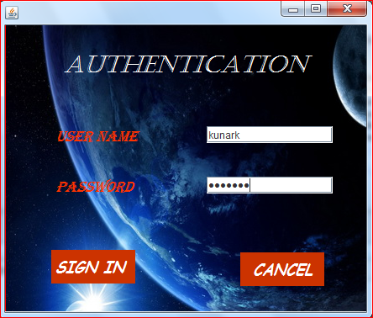

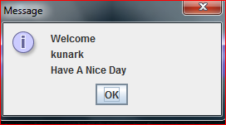

***Coding for JFrame –***

import java.sql.*;

import javax.swing.JOptionPane;

**private void jButton2ActionPerformed(java.awt.event.ActionEvent evt)** {

try {

Class.forName("java.sql.DriverManager");

Connection con=DriverManager.getConnection("jdbc:mysql://localhost:3306/ip1","root","mysql");

String user_id,password,sql;

user_id=jTextField1.getText();

password=new String(jPasswordField1.getPassword());

sql="select * from admin where username='"+user_id+"'and password ='"+password+"'";

Statement st=con.createStatement();

ResultSet rs=st.executeQuery(sql);

if(rs.next())

{

this.setVisible(false);

new ip6().setVisible(true);

JOptionPane.showMessageDialog(this,"Welcome\n"+user_id +"\nHave A Nice Day");

}

else

{

JOptionPane.showMessageDialog(this,"Invalid UserName or Password");

jPasswordField1.setText("");

}

} catch(Exception e) {

JOptionPane.showMessageDialog(this,"ERROR"+e.getMessage());

}

}

**private** **void jButton3ActionPerformed(java.awt.event.ActionEvent evt)** {

this.setVisible(false);

new ip2().setVisible(true);

}

***Frame:12th page***

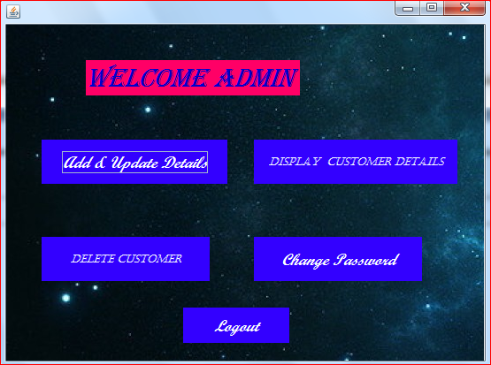

***Coding for JFrame –***

import javax.swing.JOptionPane;

**private void jButton5ActionPerformed(java.awt.event.ActionEvent evt)** {

this.setVisible(false);

new ip9().setVisible(true);

}

private void jButton3ActionPerformed(java.awt.event.ActionEvent evt) {

this.setVisible(false);

new ip7().setVisible(true);

JOptionPane.showMessageDialog(this,"USE DISPALY TABLES\n..SWEETS\n..JUICES\n..SNACKS\n..SOFT DRINKS\nTO VIEW ITEMS");

}

**private void jButton6ActionPerformed(java.awt.event.ActionEvent evt)** {

this.setVisible(false);

new ip4().setVisible(true);

}

**private void jButton4ActionPerformed(java.awt.event.ActionEvent evt)** {

this.setVisible(false);

new ip8().setVisible(true);

}

**private void jButton8ActionPerformed(java.awt.event.ActionEvent evt)** {

this.setVisible(false);

new ip14().setVisible(true);

}

***Frame:13th page***

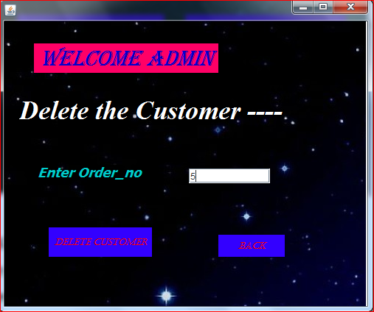

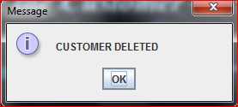

***Coding for JFrame –***

import java.sql.*;

import javax.swing.JOptionPane;

**private void jButton6jButton2ActionPerformed(java.awt.event.ActionEvent evt)** { try{

Class.forName("java.sql.DriverManager");

Connection con=DriverManager.getConnection("jdbc:mysql://localhost:3306/ip1","root","mysql");

String order_no,sql;

order_no=jTextField1.getText();

sql="delete from customer where order_no='"+order_no+"'";

Statement st=con.createStatement();

int count= st.executeUpdate(sql);

if(count>0) {

JOptionPane.showMessageDialog(this,"CUSTOMER DELETED");

jTextField1.setText("");

} else {

JOptionPane.showMessageDialog(this,"Customer Not Found");

jTextField1.setText(""); }

} catch(Exception e) {

JOptionPane.showMessageDialog(this,"ERROR"+e.getMessage());

} }

**private void jButton8ActionPerformed(java.awt.event.ActionEvent evt)** {

this.setVisible(false);

new ip6().setVisible(true);}

***Frame:14th page***

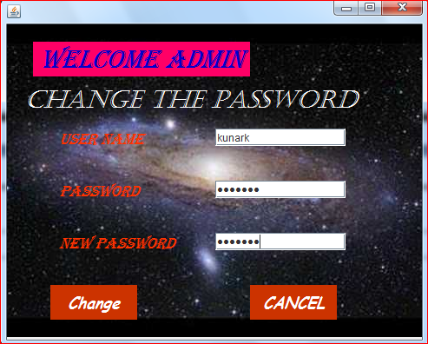 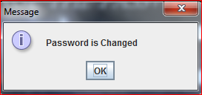

***Coding for JFrame –***

import java.sql.*;

import javax.swing.JOptionPane;

**private void jButton2ActionPerformed(java.awt.event.ActionEvent evt)** {

try {

Class.forName("java.sql.DriverManager");

Connection con=DriverManager.getConnection("jdbc:mysql://localhost:3306/ip1","root","mysql");

String user_id,password,new_password,sql;

user_id=jTextField1.getText();

password=new String(jPasswordField1.getPassword());

new_password=new String(jPasswordField2.getPassword());

sql="update admin set password='"+new_password+"' where username='"+user_id+"'and password='"+password+"'";

Statement st=con.createStatement();

int count=st.executeUpdate(sql);

if(count>0)

{

JOptionPane.showMessageDialog(null,"Password is Changed");

jPasswordField1.setText("");

jPasswordField2.setText("");

}

else

{

JOptionPane.showMessageDialog(this,"Invalid UserName or Password");

jPasswordField1.setText("");

jPasswordField2.setText("");

}

}

catch(Exception e)

{

JOptionPane.showMessageDialog(this,"ERROR"+e.getMessage());

}

}

**private void jButton3ActionPerformed(java.awt.event.ActionEvent evt)** {

this.setVisible(false);

new ip6().setVisible(true);

}

***Frame:15th page***

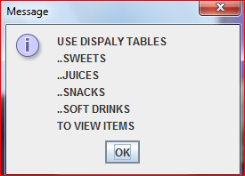

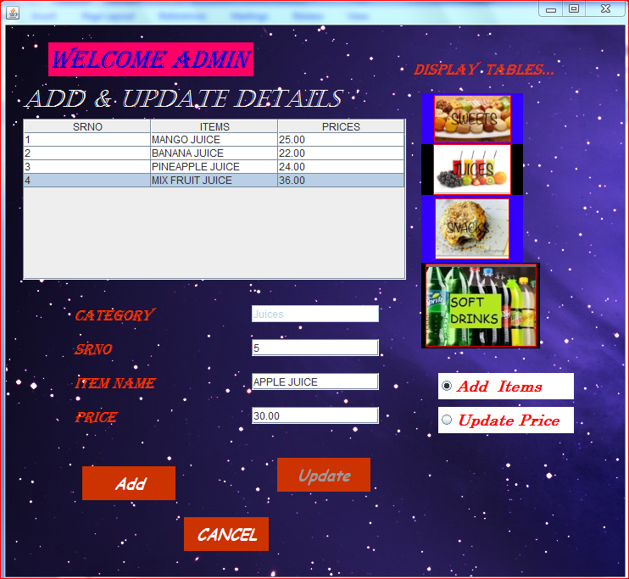

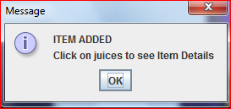

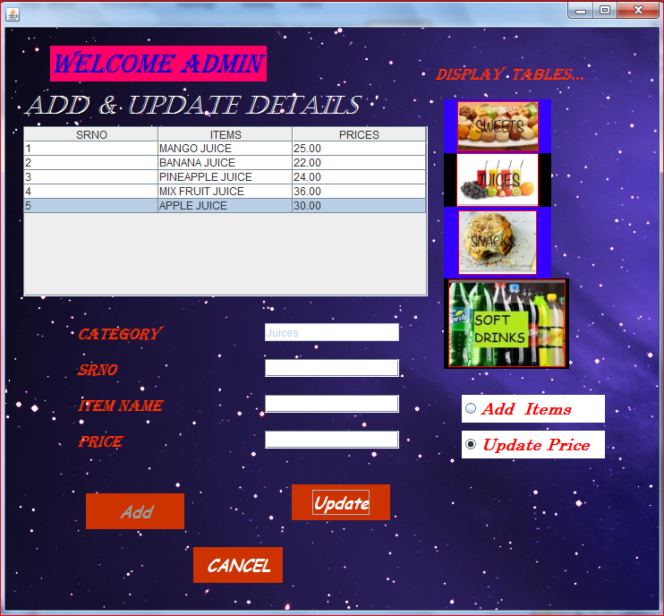 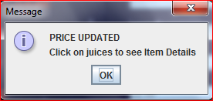

***Coding for JFrame –***

import java.sql.*;

import javax.swing.JOptionPane;

import javax.swing.table.DefaultTableModel;

**private void jButton10ActionPerformed(java.awt.event.ActionEvent evt)** {

DefaultTableModel tm=(DefaultTableModel)jTable1.getModel();

tm.setRowCount(0);

jTextField4.setText("sweets");

try {

Class.forName("java.sql.DriverManager");

Connection con=DriverManager.getConnection("jdbc:mysql://localhost/ip1","root","mysql");

Statement stmt=con.createStatement();

String query="select * from sweets";

ResultSet rs=stmt.executeQuery(query);

while (rs.next())

{

String Srno=rs.getString(1);

String Sweets=rs.getString(2);

String Price=rs.getString(3);

Object[] ob1={Srno,Sweets,Price};

tm.addRow(ob1);

}

}

catch (Exception e)

{

JOptionPane.showMessageDialog(null,e.getMessage());

}

}

**private void jButton4ActionPerformed(java.awt.event.ActionEvent evt)** {

DefaultTableModel tm=(DefaultTableModel)jTable1.getModel();

tm.setRowCount(0);

jTextField4.setText("juices");

try {

Class.forName("java.sql.DriverManager");

Connection con=DriverManager.getConnection("jdbc:mysql://localhost/ip1","root","mysql");

Statement stmt=con.createStatement();

String query="select * from juices";

ResultSet rs=stmt.executeQuery(query);

while (rs.next())

{

String Srno=rs.getString(1);

String Juices=rs.getString(2);

String Price=rs.getString(3);

Object[] ob1={Srno,Juices,Price};

tm.addRow(ob1);

}

}

catch (Exception e)

{

JOptionPane.showMessageDialog(null,e.getMessage());

}

}

**private void jButton9ActionPerformed(java.awt.event.ActionEvent evt)** {

DefaultTableModel tm=(DefaultTableModel)jTable1.getModel();

tm.setRowCount(0);

jTextField4.setText("snacks");

try {

Class.forName("java.sql.DriverManager");

Connection con=DriverManager.getConnection("jdbc:mysql://localhost/ip1","root","mysql");

Statement stmt=con.createStatement();

String query="select * from snacks";

ResultSet rs=stmt.executeQuery(query);

while (rs.next())

{

String Srno=rs.getString(1);

String Snacks=rs.getString(2);

String Price=rs.getString(3);

Object[] ob1={Srno,Snacks,Price};

tm.addRow(ob1);

}

}

catch (Exception e)

{

JOptionPane.showMessageDialog(null,e.getMessage());

}

}

**private void jButton3ActionPerformed(java.awt.event.ActionEvent evt)** {

DefaultTableModel tm=(DefaultTableModel)jTable1.getModel();

tm.setRowCount(0);

jTextField4.setText("soft_drinks");

try {

Class.forName("java.sql.DriverManager");

Connection con=DriverManager.getConnection("jdbc:mysql://localhost/ip1","root","mysql");

Statement stmt=con.createStatement();

String query="select * from soft_drinks";

ResultSet rs=stmt.executeQuery(query);

while (rs.next())

{

String Srno=rs.getString(1);

String Soft_Drinks=rs.getString(2);

String Price=rs.getString(3);

Object[] ob1={Srno,Soft_Drinks,Price};

tm.addRow(ob1);

}

}

catch (Exception e)

{

JOptionPane.showMessageDialog(null,e.getMessage());

}

}

**private void jButton5ActionPerformed(java.awt.event.ActionEvent evt)** {

this.setVisible(false);

new ip6().setVisible(true);

}

**private** **void jButton2ActionPerformed(java.awt.event.ActionEvent evt)** {

try {

Class.forName("java.sql.DriverManager");

Connection con=DriverManager.getConnection("jdbc:mysql://localhost:3306/ip1","root","mysql");

String srno , items,price ,sql;

srno=jTextField1.getText();

items=jTextField2.getText();

price=jTextField3.getText();

sql="update "+jTextField4.getText()+" set "+jTextField4.getText()+"='"+items+"',price='"+price+"'where srno="+srno;

Statement st=con.createStatement();

st.executeUpdate(sql);

JOptionPane.showMessageDialog(this,"PRICE UPDATED\nClick on "+jTextField4.getText()+" to see Item Details");

jTextField1.setText("");

jTextField2.setText("");

jTextField3.setText("");

} catch(Exception e) {

JOptionPane.showMessageDialog(this,"ERROR"+e.getMessage());

}

}

**private void jRadioButton2ActionPerformed(java.awt.event.ActionEvent evt)** {

jButton6.setEnabled(true);

jButton2.setEnabled(false);

}

**private void jRadioButton3ActionPerformed(java.awt.event.ActionEvent evt)** {

jButton2.setEnabled(true);

jButton6.setEnabled(false);}

**private void jButton6ActionPerformed(java.awt.event.ActionEvent evt)** {

try {

Class.forName("java.sql.DriverManager");

Connection con=DriverManager.getConnection("jdbc:mysql://localhost:3306/ip1","root","mysql");

String srno,item,price,sql;

srno=jTextField1.getText();

item=jTextField2.getText();

price=jTextField3.getText();

sql="insert into "+jTextField4.getText()+" values('"+srno+"','"+item+"','"+price+"')";

Statement st=con.createStatement();

st.executeUpdate(sql);

JOptionPane.showMessageDialog(this,"ITEM ADDED\nClick on "+jTextField4.getText()+" to see Item Details");

jTextField1.setText("");

jTextField2.setText("");

jTextField3.setText("");

}

catch(Exception e)

{

JOptionPane.showMessageDialog(this,"ERROR"+e.getMessage());

} }

**private void jTable1MouseClicked(java.awt.event.MouseEvent evt)** {

int i=jTable1.getSelectedRow();

DefaultTableModel m=(DefaultTableModel)jTable1.getModel();

jTextField1.setText(m.getValueAt(i, 0).toString());

jTextField2.setText(m.getValueAt(i, 1).toString());

jTextField3.setText(m.getValueAt(i, 2).toString()); }

***Frame:16th page***

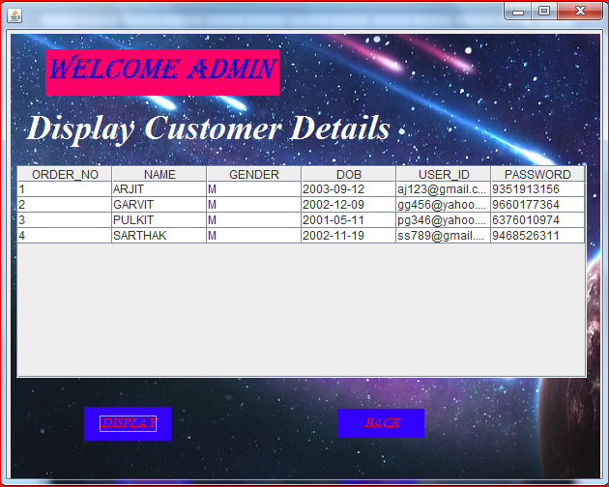

***Coding for JFrame –***

import java.sql.*;

import javax.swing.JOptionPane;

import javax.swing.table.DefaultTableModel;

**private void jButton6ActionPerformed(java.awt.event.ActionEvent evt)** {

this.setVisible(false);

new ip6().setVisible(true);

}

**private void jButton2ActionPerformed(java.awt.event.ActionEvent evt)** {

DefaultTableModel m=(DefaultTableModel)jTable2.getModel();

m.setRowCount(0);

try{

Class.forName("java.sql.DriverManager");

Connection con=DriverManager.getConnection("jdbc:mysql://localhost/ip1","root","mysql");

Statement stmt=con.createStatement();

String query="select * from customer";

ResultSet rs=stmt.executeQuery(query);

while (rs.next()){

String order_no=rs.getString(1);

String name=rs.getString(2);

String gender=rs.getString(3);

String dob=rs.getString(4);

String user_id=rs.getString(5);

String password=rs.getString(6);

m.addRow(new Object[] {order_no,name,gender,dob,user_id,password});

}

}

catch (Exception e)

{

JOptionPane.showMessageDialog(null,e.getMessage());

}

}

**7. User Manual**

## 

## 7.1 How to install Software:

### Hardware Requirement-

* Intel Pentium/Celeron or similar processor based PC at Client/Server end.
* 128 MB RAM and 4GB HDD space (for Database) is desirable.
* Standard I/O devices like Keyboard and Mouse etc.
* Printer is needed for hard-copy reports.
* Local Area Network(LAN) is required for Client-Server Installation

### Software Requirement-

* Windows 2007 OS is desirable.
* NetBeans Ver 6.9.1 or higher should be installed with JDK and JVM.
* MySQL Ver 5.0with Library Database must be present at machine.

## 

## 7.2 Working with Software:

### Project Installation

To run the project simply follow the following steps.

File ⏵Open Project... ⏵class 12 ip pro.

### Database Installation

To create the database simply follow the following steps.

**Step 1:** Copy the whole data from Notepad.

Database named – ip1 .

**Step 2:** Paste it into the MySQL Command Line Client.

Automatically the Tables will created & Records are inserted.

Note: The PC must have MySQL server with user (***root***) and password (***mysql***) . If root password is any other password, it can be changed by running MySQL Server Instance Configure Wizard.

Start ⏵Program ⏵ MySQL ⏵MySQL Server ⏵MySQL Server Instance Config Wizard

Provide current password of root and new password as “mysql” , this will change the root password.

**8. Bibliography**

In order to work on this project titled - ***Restaurant Management System,*** the following books and literature are refered by me during the various phases of development of the project.

(1) The Complete Reference Java 2.0

-by Shildit

(2)MySQL, Black Book

-by Steven Holzner

(3) Understanding SQL

– Gruber

(4) <http://www.mysql.org/>

(5) <http://www.netbeans.org>/

(6) On-line Help of NetBeans ®

(7) Informatics Practices for class XII

-by Sumita Arora

(8) Together with Informatics Practices

(9) Various Websites of Discussion Forum and software development activities.

Other than the above-mentioned books, the suggestions and supervision of my teacher and my class experience also helped me to develop this software project.